# **Name: Abdurrahman Qureshi**

# **Roll no: 210451**

## **Practical no 11: -**

**CODE:**

#include<iostream.h>

#include<conio.h>

class student

{

public:

int roll_no;

char name[30];

void getdata()

{

cout<<"\nEnter roll no and name:\n";

cin>>roll_no>>name;

}

void putdata()

{

cout<<"Roll no:"<<roll_no;

cout<<"Name: "<<name;

}

};

class marks:public student

{

public:

int m1,m2,m3;

float total,percentage;

void accept()

{

cout<<"\nEnter marks of 3 subjects:\n";

cin>>m1>>m2>>m3;

}

void display()

{

total=m1+m2+m3;

percentage=(total/300)*100;

cout<<"\nMarks of subject 1:"<<m1;

cout<<"\nMarks of subject 2:"<<m2;

cout<<"\nMarks of subject 3:"<<m3;

cout<<"\nTotal:"<<total;

cout<<"\nPercentage:"<<percentage;

}

};

void main()

{

clrscr();

class marks m1;

m1.getdata();

m1.putdata();

m1.accept();

m1.display();

getch();

}

**OUTPUT:**

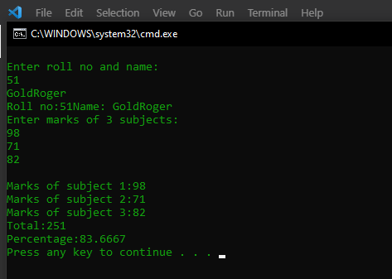

2.

**CODE:**

#include<iostream.h>

#include<conio.h>

class employee

{

public:

int emp_no;

char emp_name[50];

char emp_designation[20];

void getdata()

{

cout<<"Enter employee number, name and designation:\n";

cin>>emp_no>>emp_name>>emp_designation;

}

void putdata()

{

cout<<"Employee number: "<<emp_no<<endl;

cout<<"Employee name: "<<emp_name<<endl;

cout<<"Employee designation: "<<emp_designation<<endl;

}

};

class salary:public employee

{

public:

int basic_sal,hra,da,gross_sal;

void accept()

{

cout<<"Enter HRA, DA and Basic salary:\n";

cin>>hra>>da>>basic_sal;

}

void display()

{

gross_sal=hra+da+basic_sal;

cout<<"\nHRA= "<<hra;

cout<<"\nDA= "<<da;

cout<<"\nBasic= "<<basic_sal;

cout<<"Gross= "<<gross_sal;

}

};

void main()

{

clrscr();

class salary s1;

s1.getdata();

s1.putdata();

s1.accept();

s1.display();

getch();

}

**OUTPUT:**

